Please read this brief carefully before completing the role

JOB: Taste test & review XXXXX
WEBSITE: Amazon.co.uk
COMPLETION: As per the dates on the role you have booked onto
PAY: £6 as a contribution towards your shopping for your time
EXPENSES: £xxxx to spend on 1 unit of xxxx

WHAT DOES A GOOD JOB LOOK LIKE:
Review of ‘INSERT PRODUCT NAME’ on the Amazon site showing as a verified purchase
Here’s an example for another product to show what good looks like

REQUIREMENTS OF THE ROLE:
- Please watch this video before you complete your online review task; https://share.vidyard.com/watch/yZa56nF4k34N2fsT9kriQi?
- Purchase INSERT PRODUCT NAME’ on Amazon via the XXXXX store
- Leave a realistic time between purchase and review to allow tasting of the product before reviewing – this should be at least 48 hours after you have received your order, if you don’t your review may be declined.

PRODUCT INFORMATION: INSERT SCREEN SHOT OF EXACTLY HOW THE PRODUCT IS SHOWN ON AMAZON AS PER THE BELOW
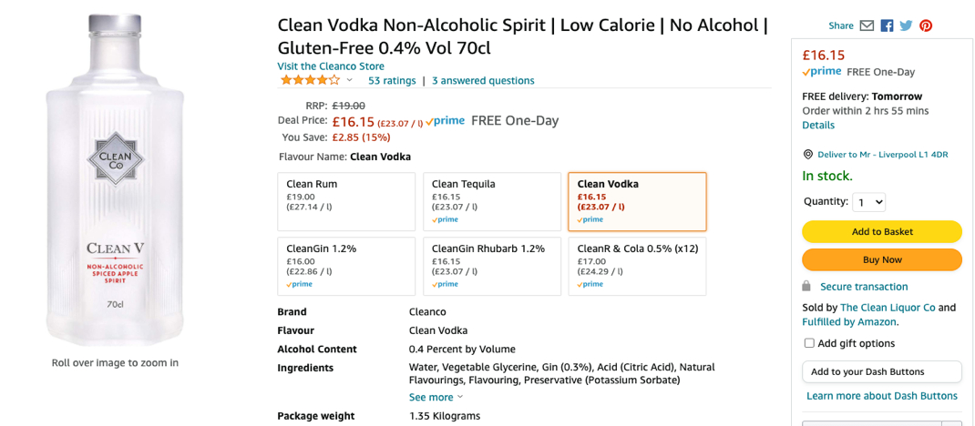

ADD ANY RELEVANT PERFECT SERVE / PRODUCT / MARKETING INFORMATION

HOW TO COMPLETE THE ROLE
- Follow the ‘perfect serve’ to try the product at its best
- Once you’ve tried new products you need to review them on Amazon on the product page
- To do this, visit Amazon and search for each product.
- You will see the link ‘write a review’ to the right of the product image.
- Click write a review to leave your reviews.
- When writing your review DO NOT put the name of the product as the title of the review. Consider the impression your review gives – other shoppers will read and can be influenced by your comments. Make your review genuine, unique and fair.
- Please ensure you take a screen shot or photo of the review before you post it so we can see it.
- We need to see a good review title & your review with star rating as part of your screenshot
- You will also need to input the text of your review in full into your timesheet too.
- Please ensure your reviews are different for the products purchased
- You will need to submit a copy of your receipt with your timesheet – be sure the purchase confirmation can be clearly seen. You may submit a receipt with multiple reviewed products on but it is only valid for reviews by a single wigwammer.
- You will receive an email when your review has been posted on Amazon, only at this point should you then submit your timesheet with a copy of the email

POINTS TO NOTE:
- YOU CAN ONLY REVIEW A PRODUCT ONCE.
- All claimed expenses are independently audited
- You can only claim reimbursement for products on a receipt once
- It is not acceptable for different workers to claim for the same products
- If instructions on the brief are not followed correctly then your timesheet may not be approved. This may also affect your rating
- If you are ever unsure of how to complete the role / reporting then please refer to our Frequently Asked Questions here or contact us via Live chat

REPORTING QUESTIONS TO COMPLETE AS PART OF YOUR TIMESHEET
- Date you placed your order
- Date you received your order
- Date you received your email asking you to review (not guaranteed)
- Date of you left your review
- What nickname did you used when leaving your review?
- What star rating did you give INSERT PRODUCT NAME
- Text of Review
- Upload screen shot of your review of INSERT PRODUCT NAME before posting
- Would you buy this product again?
- Date you received your email confirming your email had be published (not submitted)
- Screenshot of email received to confirm your review has been published
- Screenshot of your now live amazon review
- Any other feedback?

Please ensure you submit your timesheet as soon as you have completed the role.
Timesheets will automatically expire 2wks after the job deadline unless stated otherwise.

PLEASE DELETE THIS SECTION BEFORE SAVING YOUR FILE AS A PDF (remember to reduce the images as max file size is 5MB)
To get your job loaded & live please log into your account https://hirer.redwigwam.com/login/
On your dashboard go to JOBS – ADD A JOB, Select Sector – RETAIL, Select Job Type – ONLINE PRODUCT REVIEWER, Select template job - AMAZON.com - Online Purchase, Taste, Test and review XXXX £6 + product costs
You will then need to update the job according to your requirement and also ensure you amend the products in the reporting section too from XXXXs / ABC.
If you need help then please pop onto live chat or email catherine@redwigwam.com

